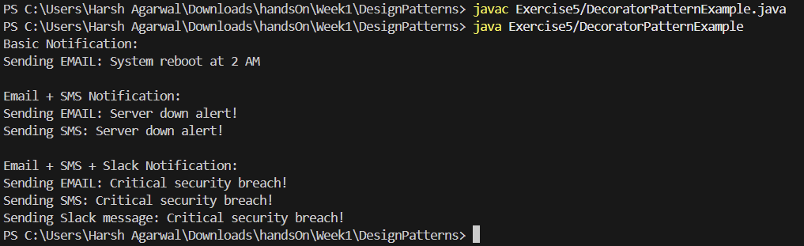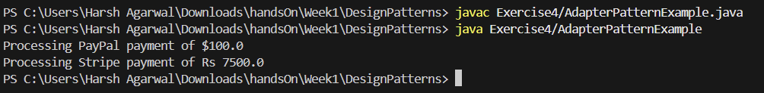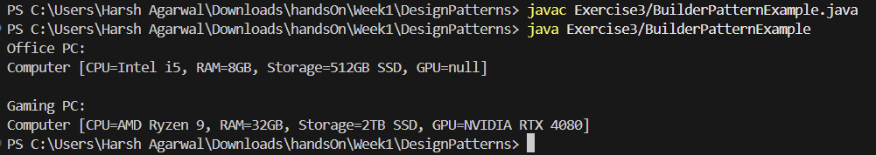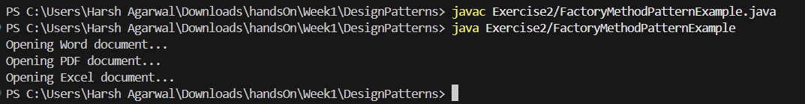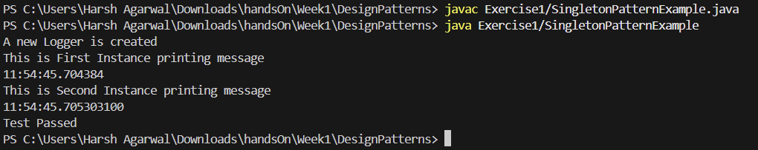OUTPUT OF ALL ASSIGNMENT QUESTIONS

Exercise 5

Exercise 4

Exercise 3

Exercise 2

Exercise 1

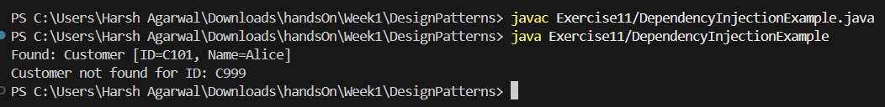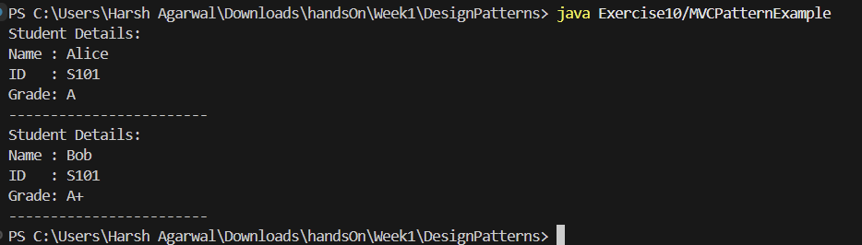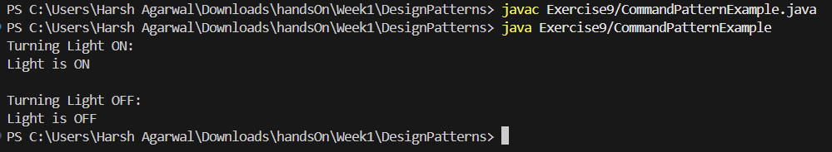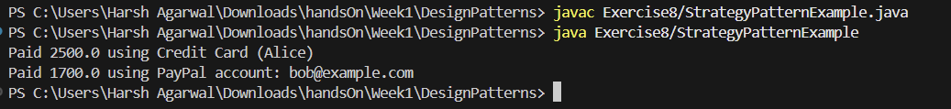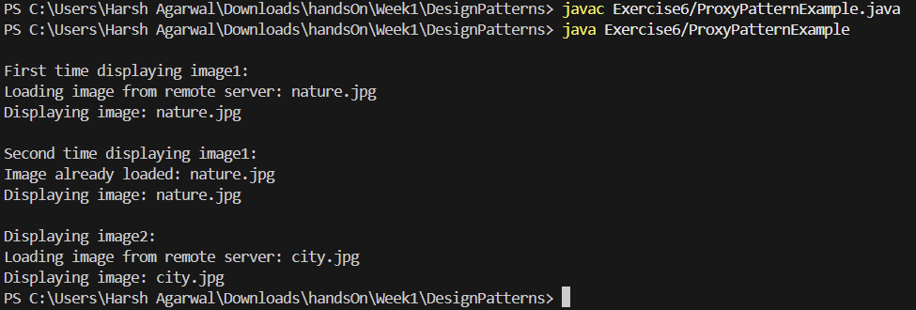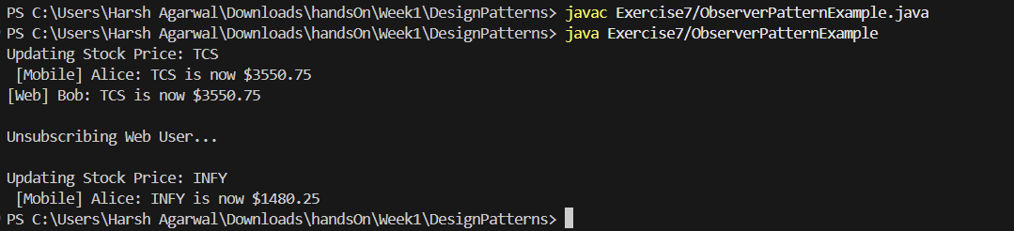

Exercise 10

Exercise 11

Exercise 9

Exercise 8

Exercise 7

Exercise 6